# Lecture # 9:

**Objective:**

* Date Time Picker

# Date Time Picker:

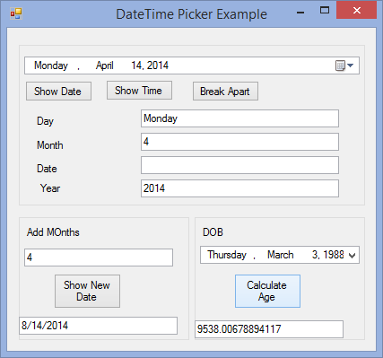

using System;

using System.Collections.Generic; using System.ComponentModel; using System.Data;

using System.Drawing; using System.Linq; using System.Text;

using System.Windows.Forms;

namespace COMBOBOX

{

public partial class dateTimePickerExample : Form

{

public dateTimePickerExample()

{

InitializeComponent();

}

private void btnDate_Click(object sender, EventArgs e)

{

MessageBox.Show(dateTimePicker1.Value.ToShortDateString());

}

private void btnTime_Click(object sender, EventArgs e)

{

MessageBox.Show(dateTimePicker1.Value.ToShortTimeString());

}

private void btnBreak_Click(object sender, EventArgs e)

{

txtDay.Text = dateTimePicker1.Value.DayOfWeek.ToString(); txtYear.Text = dateTimePicker1.Value.Year.ToString(); txtMonth.Text = dateTimePicker1.Value.Month.ToString();

}

private void button1_Click(object sender, EventArgs e)

{

txtAge.Text=dateTimePicker1.Value.Subtract(dateTimePicker2.Value).TotalDays.T oString();

}

private void btnShowNew_Click(object sender, EventArgs e)

{

txt.Text = dateTimePicker1.Value.AddMonths(int.Parse(txtAddMonths.Text)).ToShortDateStri ng();

}

}

}